Lab Report: Cell Transport: Diffusion and Osmosis

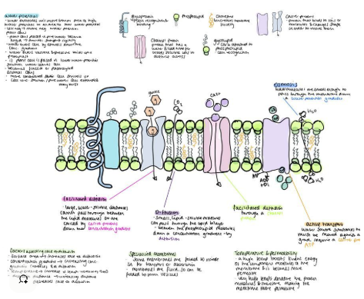

Abstract
In this series of five experiments, we took a closer look at how cellular respiration depends on the movement of substances across membranes. We explored different processes like diffusion, osmosis, and tonicity, as well as how molecular weight and lipid solubility affect the movement of particles. By watching how particles move in liquids, observing dye diffusion in agar, measuring mass changes across dialysis membranes, studying hemolysis in various solute concentrations, and assessing permeability to alcohols, we got a better understanding of how cells keep their internal environments stable for respiration. Overall, these results pointed to the crucial role of selective permeability and osmotic balance in keeping cells functioning well.

Introduction

For cells to carry out respiration effectively, they need to maintain a stable internal environment. This stability is achieved through transport across the plasma membrane that’s controlled by diffusion, osmosis, and how solutes interact with each other. The five experiments we conducted modeled important behaviors of membranes. For instance, diffusion illustrates how gases and solutes spread out, osmosis shows us how water balances out, and hemolysis tests give us insight into how solute concentrations can impact cell integrity. Together, these experiments demonstrate how transport processes are vital for respiration by regulating the movement of solutes and water.

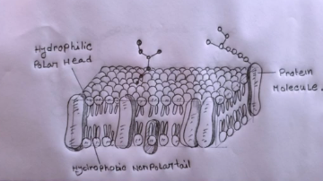
Figure 1: Structure of Cell membrane

Experiment 1: Brownian Motion
Objective: To observe random molecular movement caused by collisions with water molecules.
Method: Carmine dye was placed in water and observed under the microscope.
Results: Particles of dye moved continuously in random directions.
Conclusion: This demonstrated Brownian motion and confirmed the presence of constant molecular activity.
Experiment 2: Diffusion in Agar
Objective: To compare diffusion rates of molecules with different sizes.
Method: Agar plates were infused with potassium permanganate and methylene blue. Results: Potassium permanganate diffused faster than methylene blue due to its smaller molecular weight.
Time | Distance travelled by methylene blue | Distance travelled by potassium permanganate
20 min | 3 mm | 5 mm
40 min | 4 mm | 6 mm
60 min | 5 mm | 7 mm

Conclusion: Smaller molecules diffuse more quickly than larger ones, demonstrating the effect of size on diffusion rate.
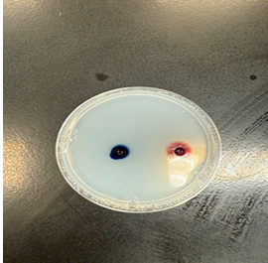
Figure 2: Diffusion of dyes through agar showing rate differences

Experiment 3: Osmosis with Dialysis Bags
Objective: To examine water movement across a semi-permeable membrane.
Method: Dialysis bags filled with sucrose solutions were submerged in water.
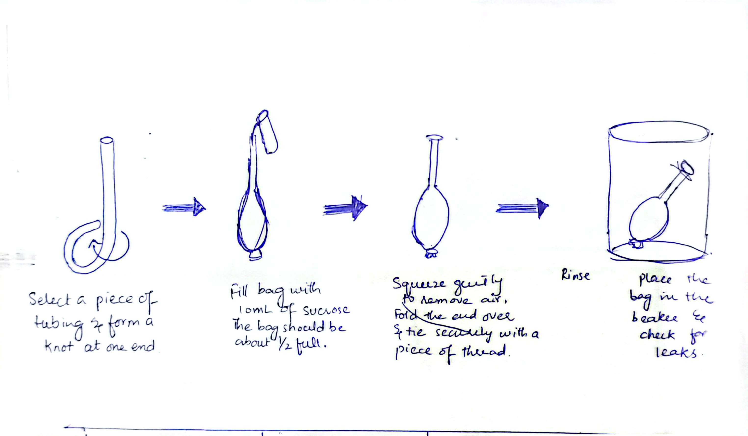
Figure 3: Instructions on how to set a dialysis tubbing for the osmosis experiment
Results: Bags in hypotonic solutions gained mass, while those in hypertonic solutions lost mass.
Time (min) | Bag 1 (dH₂O in dH₂O) Mass (g) | Δ Mass (g) | Bag 2 (15% Sucrose in dH₂O) Mass (g) | Δ Mass (g)
0 | 11.72 | – | 11.41 | –
15 | 12.59 | +0.87 | 12.16 | +0.75
30 | 13.40 | +0.81 | 12.74 | +0.58
45 | 14.07 | +0.67 | 13.04 | +0.30
60 | 13.88 | –0.19 | 13.54 | +0.50

Time (min) | Bag 3 (30% Sucrose in dH₂O) Mass (g) | Δ Mass (g) | Bag 4 (dH₂O in 30% Sucrose) Mass (g) | Δ Mass (g)
0 | 108.30 | – | 116.91 | –
15 | 109.87 | +1.57 | 118.20 | +1.29
30 | 111.62 | +1.75 | 119.85 | +1.65
45 | 112.94 | +1.32 | 120.44 | +0.59
60 | 113.80 | +0.86 | 121.10 | +0.66

Conclusion: Water moves from hypotonic to hypertonic environments, confirming osmosis.
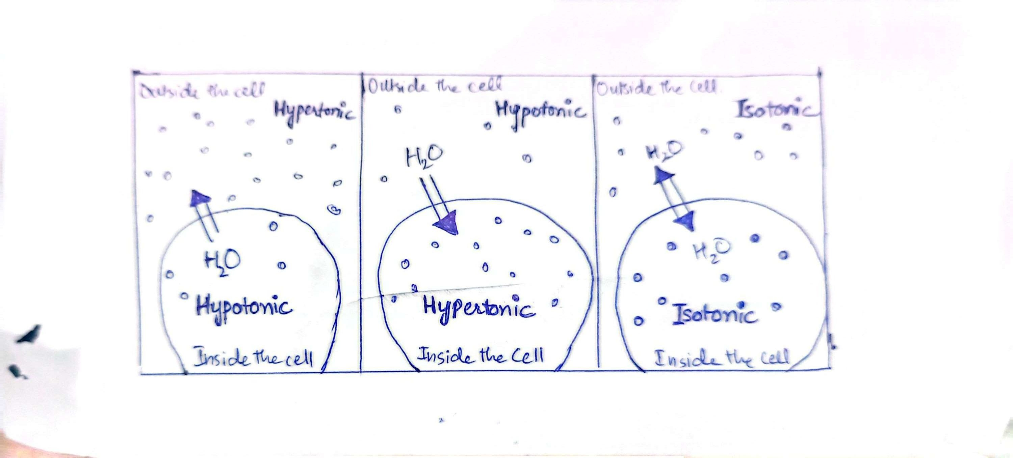
Figure 4: Passive transport/ Osmosis. Movement of water based on chemical composition of the cell environment

Experiment 4: Hemolysis in Red Blood Cells
Objective: To observe the effect of tonicity on animal cells.
Method: Red blood cells were placed in isotonic, hypotonic, and hypertonic solutions. Results: Cells hemolyzed in hypotonic solutions, crenated in hypertonic solutions, and remained intact in isotonic solutions.
Solution | Tube 1 1/4 M | Tube 2 1/6 M | Tube 3 1/8 M | Tube 4 1/10 M | Tube 5 1/12 M | Tube 6 1/14 M | Tube 7 1/16 M | Tube 8 1/18 M
Glucose | Cloudy — | Positive + | Positive + | Positive + | Positive + | Positive + | Positive + | Positive +
NaCl | Cloudy — | Cloudy — | Cloudy — | Cloudy — | Positive + | Positive + | Positive + | Positive +

Conclusion: The integrity of animal cells depends on the osmotic balance of their environment.
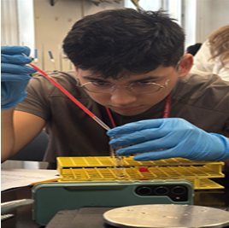
Figure 5: Hemolysis and crenation of red blood cells under varying tonicities

Experiment 5: Lipid Solubility in Alcohols
Objective: To test how lipid solubility affects membrane permeability.
Method: Red blood cells were exposed to methanol, ethanol, and propanol.
Results: Propanol caused hemolysis fastest, followed by ethanol, then methanol.
Tube | Alcohol | Formula | Partition Coefficient | Time until Hemolysis (Seconds)
1 | Methyl alcohol (methanol) | CH₃OH | 0.010 | 13
2 | Ethyl alcohol (ethanol) | C₂H₅OH | 0.036 | 10
3 | Propyl alcohol (propanol) | C₃H₇OH | 0.156 | 3

Conclusion: Greater lipid solubility increases membrane penetration, accelerating cell damage.
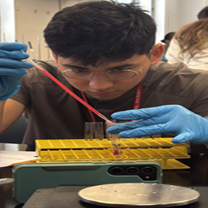
Figure 6: Alcohol-induced hemolysis showing faster cell disruption with propanol
General conclusion:
The five experiments demonstrated that membrane transport governs cellular homeostasis and directly affects processes essential for respiration. The Diffusion is influenced by the molecular weight. The osmosis depends on solute gradients and the cell integrity is controlled by external tonicity. The Lipid-soluble molecules cross the membranes more readily while reinforcing the importance of membrane.

